**ASSIGNMENT 2**

|  |  |
| --- | --- |
| Assignment Date | 28th September 2022 |
| Student name | Gitanjali.S |
| Student Roll Number | 211519106043 |
| Maximum Marks | 2 Marks |

**Question-1:**

Create form of type input text, email, password, radio button, text area, drop down and navigate to successor page and display files of form in table (CSS, HTML)

**Solution:**

<!DOCTYPE html>

<html lang="en-us">

<head>

<meta charset="UTF-8">

<title>Registaration Form</title>

<link rel="stylesheet" href="style1.css">

<script type="text/javascript" lang="javascript" src="./responsiveRegistaration.js"></script>

</head>

<body>

<form>

<h1>Student Registration Form</h1>

<fieldset>

<legend>PERSONAL DETAILS</legend>

<div>

<div class="container">

<div class="row">

<div class="col-10">

<label for="fname">First Name:</label>

</div>

<div class="col-90">

<input type="text" id="fname" name="firstname" placeholder="Enter your first name">

</div>

</div>

<div class="row">

<div class="col-10">

<label for="lname">Last Name:</label>

</div>

<div class="col-90">

<input type="text" id="lname" name="lastname" placeholder="Enter your last name">

</div>

</div>

<div class="row">

<div class="col-10">

<label for="email">Email:</label>

</div>

<div class="col-90">

<input type="email" id="email" name="email" placeholder="it should contain @,.">

</div>

</div>

<div class="row">

<div class="col-10">

<label for="mobile">Mobile:</label>

</div>

<div class="col-90">

<input type="tel" id="mobile" name="mobile" placeholder="only 10 digits are allowed">

</div>

</div>

<div class="row">

<div class="col-10">

<label for="gender" required>Gender:</label>

</div>

<div class="col-90">

<input type="radio" id="male" name="gender" value="male"/>Male

<input type="radio" id="female" name="gender" value="female"/>Female

</div>

</div>

<div class="row">

<div class="col-10">

<label for="dob">Date Of Birth:</label>

</div>

<div class="col-90">

<input type="Date" id="dob" name="dob">

</div>

</div>

<div class="row">

<div class="col-10">

<label for="address">Address:</label>

</div>

<div class="col-90">

<textarea name="address" id="address" cols="30" rows="10"></textarea>

</div>

</div>

<div class="row">

<div class="col-10">

<label for="city">City:</label>

</div>

<div class="col-90">

<input type="text" id="city" name="city" maxlength="10">

</div>

</div>

<div class="row">

<div class="col-10">

<label for="pincode">Area PIN:</label>

</div>

<div class="col-90">

<input type="number" id="pin" name="pin" maxlength="6">

</div>

</div>

<div class="row">

<div class="col-10">

<label for="state">State:</label>

</div>

<div class="col-90">

<input type="text" id="state" name="state">

</div>

</div>

<div class="row">

<div class="col-10">

<label for="qualification" required >Qualification:</label>

</div>

<div class="col-90">

<select name="qualification" id="qualification">

<option value=" ">Select Qualification:</option>

<option value="Graduation">Graduation</option>

<option value="BTech.">BTech.</option>

<option value="MTech.">MTech.</option>

<option value="MCA">MCA</option>

<option value="BCA">BCA</option>

</select>

</div>

</div>

<div class="row">

<div class="col-10">

<label for="specialization">Specialization:</label>

</div>

<div class="col-90">

<input type="checkbox" class="specialization" id="cs" name="specialization[]" value="Computer Science">Computer Science<br/>

<input type="checkbox" class="specialization" id="it" name="specialization[]" value="Information Technology">Information Technology<br/>

<input type="checkbox" class="specialization" id="ca" name="specialization[]" value="Computer Architecture">Computer Architecture<br/>

<input type="checkbox" class="specialization" id="tc" name="specialization[]" value="Tele Communication">Tele Communication<br/>

</div>

</div>

<div class="row">

<div class="col-10">

<label for="password">Password:</label>

</div>

<div class="col-90">

<input type="password" id="password" name="password" maxlength="8">

</div>

</div>

<div class="row">

<input type="submit" value="Register" onclick="SaveStudentDetails()">

</div>

</div>

</fieldset>

</form>

</body>

</html>

**OUTPUT:**

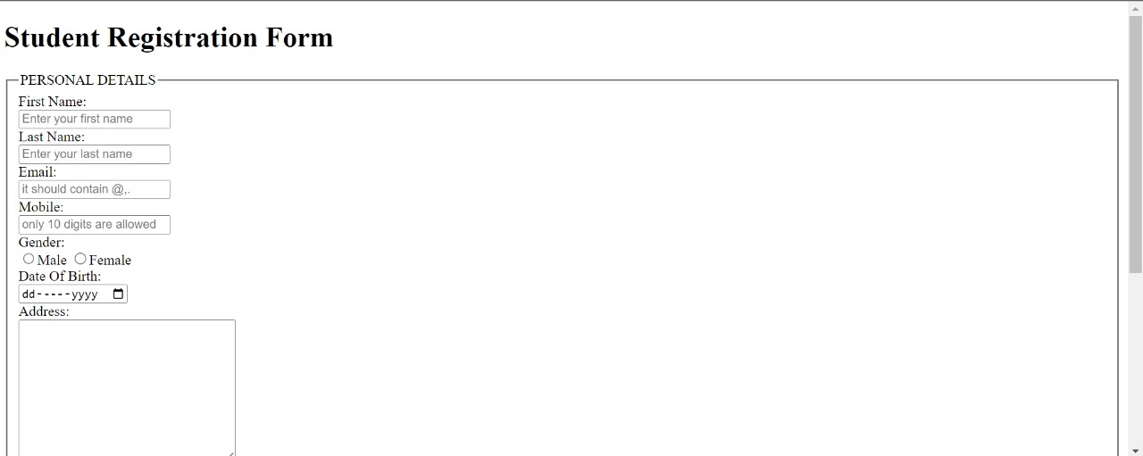

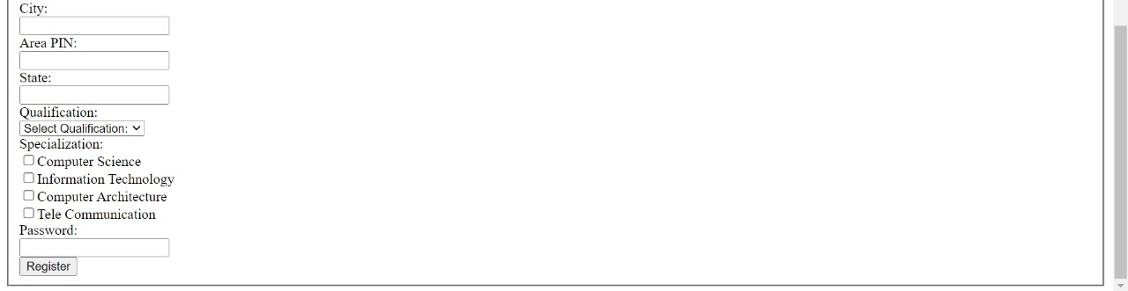

**Question-2:**

For the CSS create external style sheet for above task (separate CSS file and link that in html)

**Solution:**

*{box-sizing: border-box;

}

input[type=text], input[type=email], input[type=number], input[type=select], input[type=date],input[type=select],input[type=password], input[type=tel]

{

width: 45%;

padding: 12px;

border: 1px solid rgb(168, 166, 166);

border-radius: 4px;

resize: vertical;

}

textarea{

width:45%;

padding: 12px;

border: 1px solid rgb(168, 166, 166);

border-radius: 4px;

resize: vertical;

}

input[type=radio],input[type=checkbox]{

width: 1%;

padding-left: 0%;

border: 1px solid rgb(168, 166, 166);

border-radius: 4px;

resize: vertical;

}

h1{

font-family: Arial;

font-size: x-large;

font-style: normal;

font-weight: bold;

color: black;

text-align: center;

text-decoration: underline;

}

label{

padding: 12px 12px 12px 0;

display: inline-block;

}

input[type=submit] {

background-color: #4CAF50;

color: white;

padding: 12px 20px;

border: none;

border-radius: 4px;

cursor: pointer;

float:left;

}

input[type=submit]:hover {

background-color: #32a336;

}

.container{

border-radius: 5px;

background-color:#f2f2f2;

padding: 20px;

}

.col-10{

float: left;

width:10%;

margin-top: 6px;

}

.col-90{

float: left;

width: 90%;

margin-top: 6px;

}

.row:after{

content: "";

display: table;

clear: both;

}

@media screen and (max-width: 600px) {

.col-10,.col-90,input[type=submit]{

width: 100%;

margin-top: 0;

}

}

**OUTPUT:**

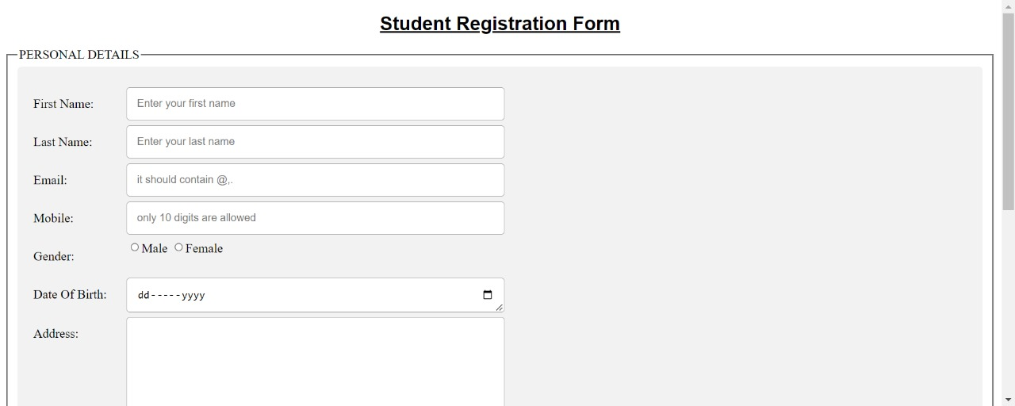

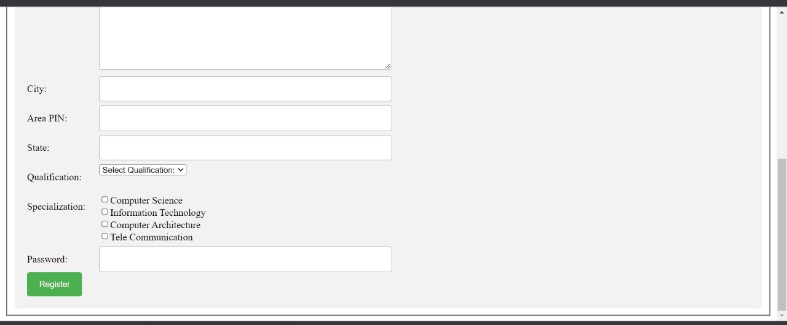

**Question-3:**

Create sample program for Flask HTTP methods (list or map and perform operations of PUT, GET, DELETE and POST)

**Solution:**

From flask import Flask ,request,json

app=Flask(_name_)

cars={"1":"Lamborghini", "2":"Ferrari" , "3":"Porsche" , "4":"Landrover" , "5":"Bugatti", "6":"Mercedes" ,"7":"Rolls-Royce" , "8":"BMW"}

@app.route('/data' ,methods=['GET','POST'])

def api():

if request.method=='GET':

return cars

if request.method=='POST':

data=request.json

cars.update(data)

return 'data got inserted' @app.route("/data/<id>",methods=['PUT'])

def update(id):

data=request.form['items']

cars[str(id)]=data

return 'data updated' @app.route("/data/<id>",methods=["DELETE"])

def deleteoperation(id):

cars.pop(str(id))

return 'data deleted' if_name=='main_':

app.run(debug=True)

**Output:**

